Violence prevention: Standards or criteria for best / effective / good practice

Note: This document collects key standards for best, effective, or good practice in violence prevention. Many of these standards are from items available in full text, at the listed URLs.
Compiled by Michael Flood, August 2020.

The standards are from the following documents:

Our Watch. (2017). Putting the prevention of violence against women into practice: How to Change The Story. Melbourne: Our Watch. 2
Kerr-Wilson, A.; Gibbs, A.; McAslan Fraser E.; Ramsoomar, L.; Parke, A.; Khuwaja, HMA.; and Rachel Jewkes. (2020). A rigorous global evidence review of interventions to prevent violence against women and girls. Pretoria, South Africa: What Works to prevent violence among women and girls global Programme. 3
Nation, M., Crusto, C., Wandersman, A., Kumpfer, K. L., Seybolt, D., Morrissey-Kane, E., & Davino, K. (2003). What Works in Prevention: Principles of Effective Prevention Programs. American Psychologist, 58(6-7), 449-456 (p. 452). 4
Virginia Sexual & Domestic Violence Action Alliance (VSDVAA). (2009). Guidelines for the Primary Prevention of Sexual Violence & Intimate Partner Violence. Richmond, VA: Virginia Sexual & Domestic Violence Action Alliance (p. 9). 5
Casey, E.A., and T.P. Lindhorst. (2009). Toward a multi-level, ecological approach to the primary prevention of sexual assault. Trauma, Violence, & Abuse 10: 91-114 (p. 97) 6
Gleeson, Cara, Sarah Kearney, Loksee Leung, and Joanna Brislane. (2015). Respectful Relationships Education in schools: evidence paper. Melbourne: Our Watch. 7
Wells, L., Flood, M., Boutilier, S., Goulet, S., & Dozois, E. (2020). Supporting Best Practices: Guidelines For Funding Programs that Engage and Mobilize Men and Boys in Violence Prevention. Alberta, Canada: Shift: The Project to End Domestic Violence and Alberta Council of Women’s Shelter. 8
Flood, M. (2018). Engaging Men and Boys in Violence Prevention, Palgrave Macmillan. 9
Flood, M., L. Fergus, and M. Heenan. (2009). Respectful Relationships Education: Violence prevention and respectful relationships education in Victorian secondary schools. Melbourne: Department of Education and Early Childhood Development, State of Victoria. 10
Michau, L., Horn, J., Bank, A., Dutt, M., & Zimmerman, C. (2015). Prevention of violence against women and girls: lessons from practice. The Lancet, 385(9978), 1672-1684. 13

Our Watch. (2017). Putting the prevention of violence against women into practice: How to Change The Story. Melbourne: Our Watch.

From the table of contents:
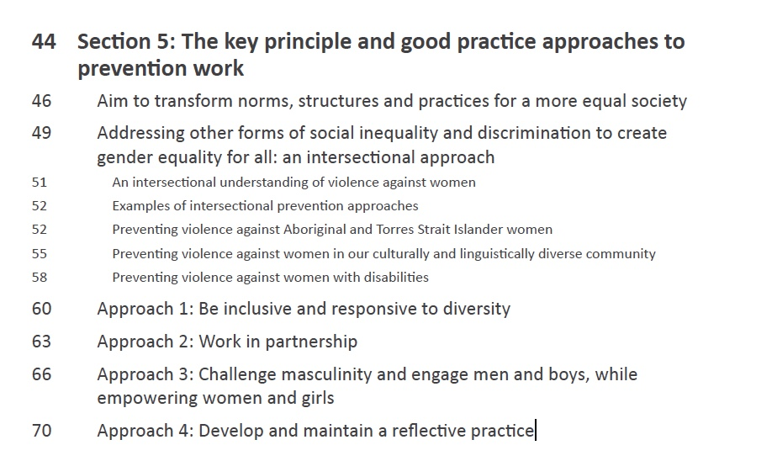

URL: https://www.ourwatch.org.au/What-We-Do/Our-Watch-Handbook

Kerr-Wilson, A.; Gibbs, A.; McAslan Fraser E.; Ramsoomar, L.; Parke, A.; Khuwaja, HMA.; and Rachel Jewkes. (2020). A rigorous global evidence review of interventions to prevent violence against women and girls. Pretoria, South Africa: What Works to prevent violence among women and girls global Programme.

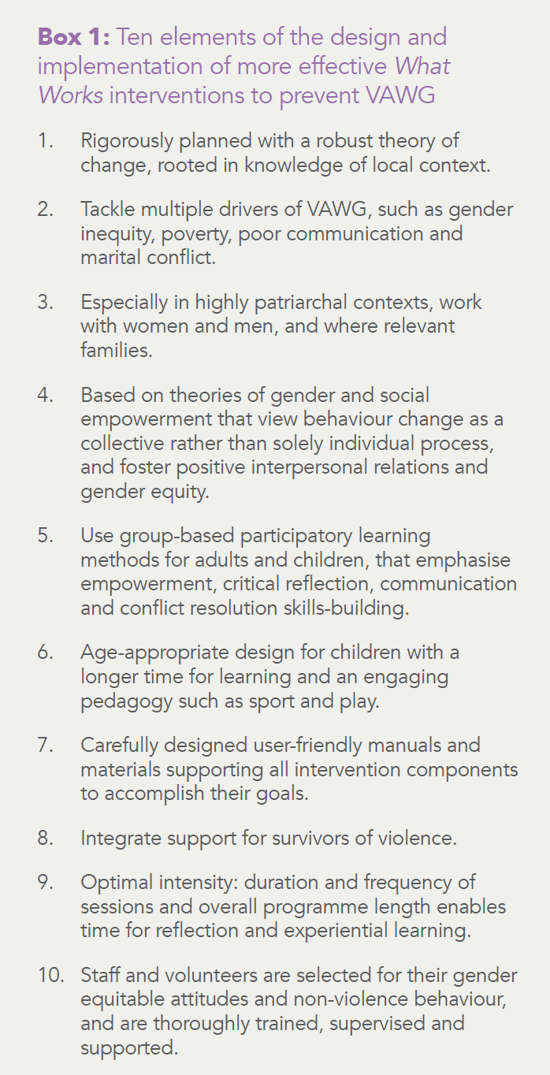

URL: https://www.whatworks.co.za/resources/evidence-reviews

Nation, M., Crusto, C., Wandersman, A., Kumpfer, K. L., Seybolt, D., Morrissey-Kane, E., & Davino, K. (2003). What Works in Prevention: Principles of Effective Prevention Programs. American Psychologist, 58(6-7), 449-456 (p. 452).

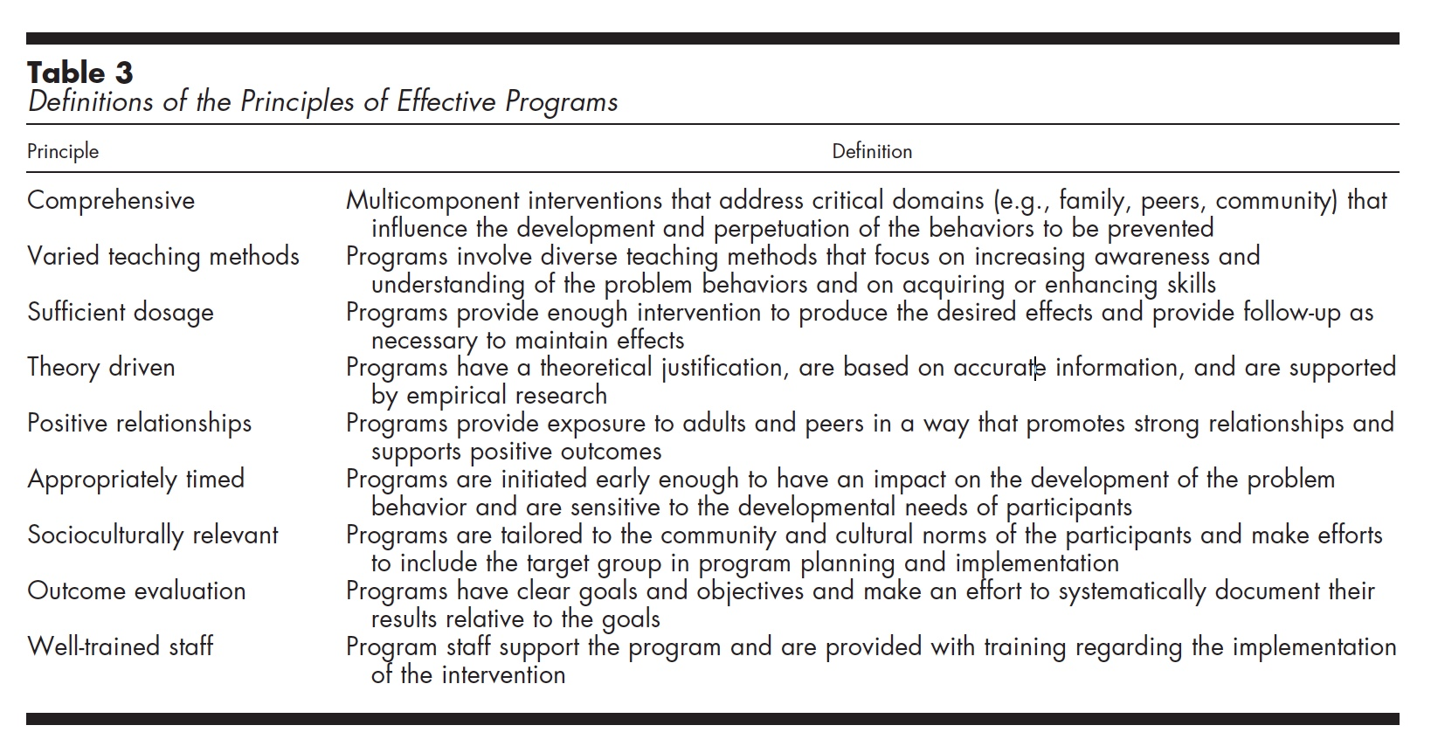

Virginia Sexual & Domestic Violence Action Alliance (VSDVAA). (2009). Guidelines for the Primary Prevention of Sexual Violence & Intimate Partner Violence. Richmond, VA: Virginia Sexual & Domestic Violence Action Alliance (p. 9).
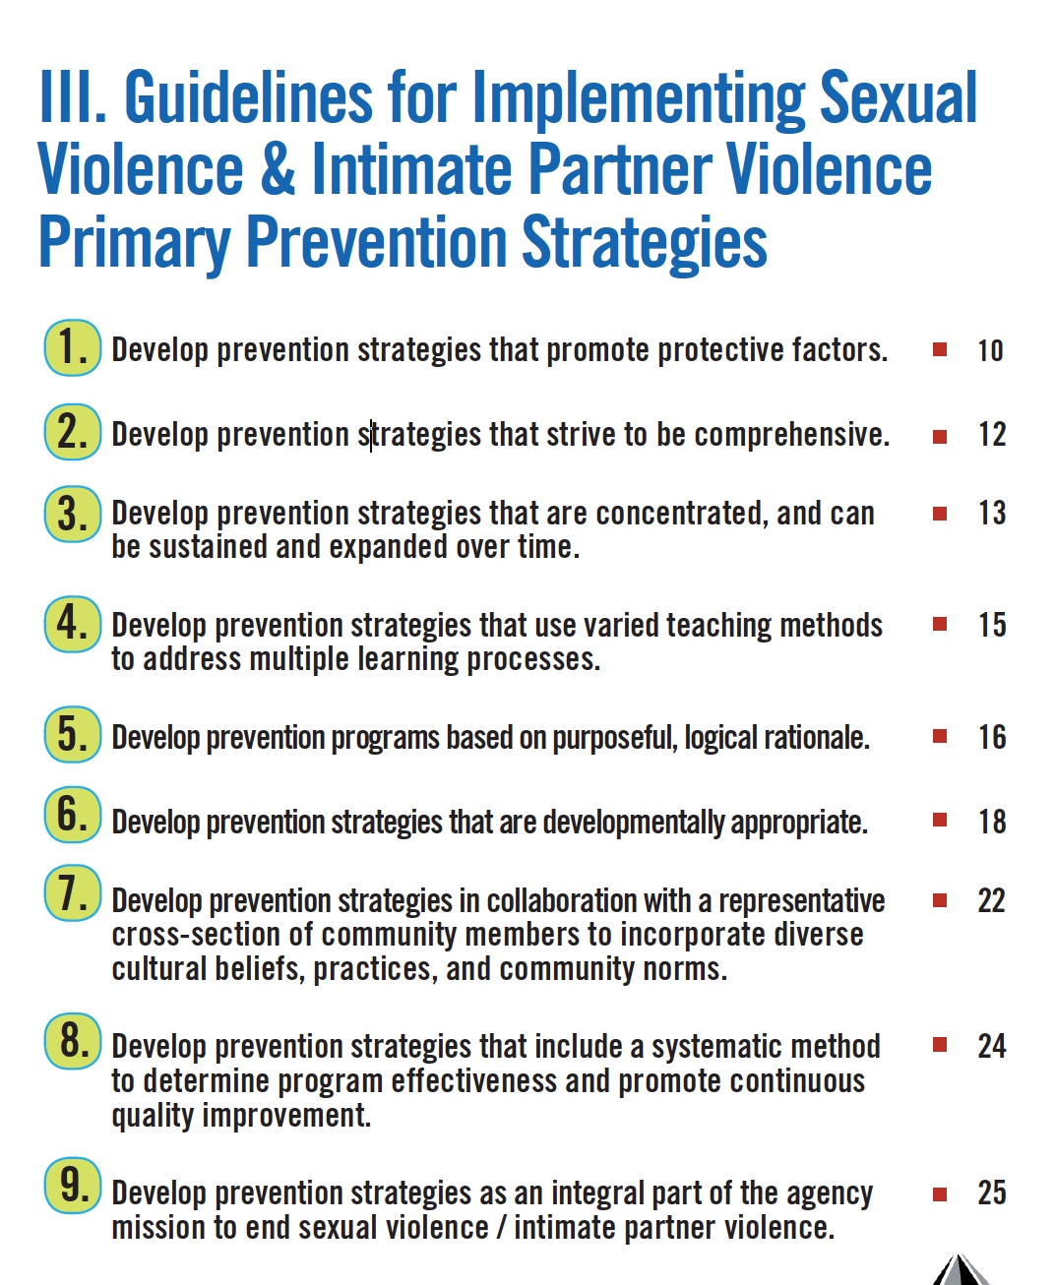

URL: https://preventipv.org/materials/guidelines-primary-prevention-sexual-violence-and-intimate-partner-violence

Casey, E.A., and T.P. Lindhorst. (2009). Toward a multi-level, ecological approach to the primary prevention of sexual assault. Trauma, Violence, & Abuse 10: 91-114 (p. 97)
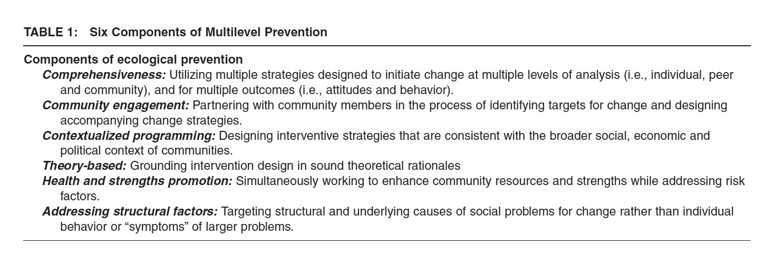

Gleeson, Cara, Sarah Kearney, Loksee Leung, and Joanna Brislane. (2015). Respectful Relationships Education in schools: evidence paper. Melbourne: Our Watch.

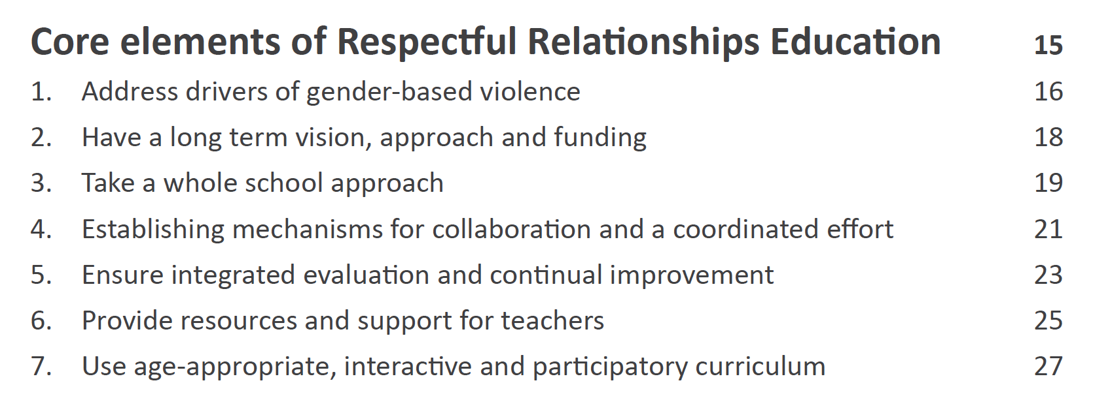

URL: https://www.ourwatch.org.au/resource/evidence-paper-respectful-relationships-education-in-schools/

Wells, L., Flood, M., Boutilier, S., Goulet, S., & Dozois, E. (2020). Supporting Best Practices: Guidelines For Funding Programs that Engage and Mobilize Men and Boys in Violence Prevention. Alberta, Canada: Shift: The Project to End Domestic Violence and Alberta Council of Women’s Shelter.

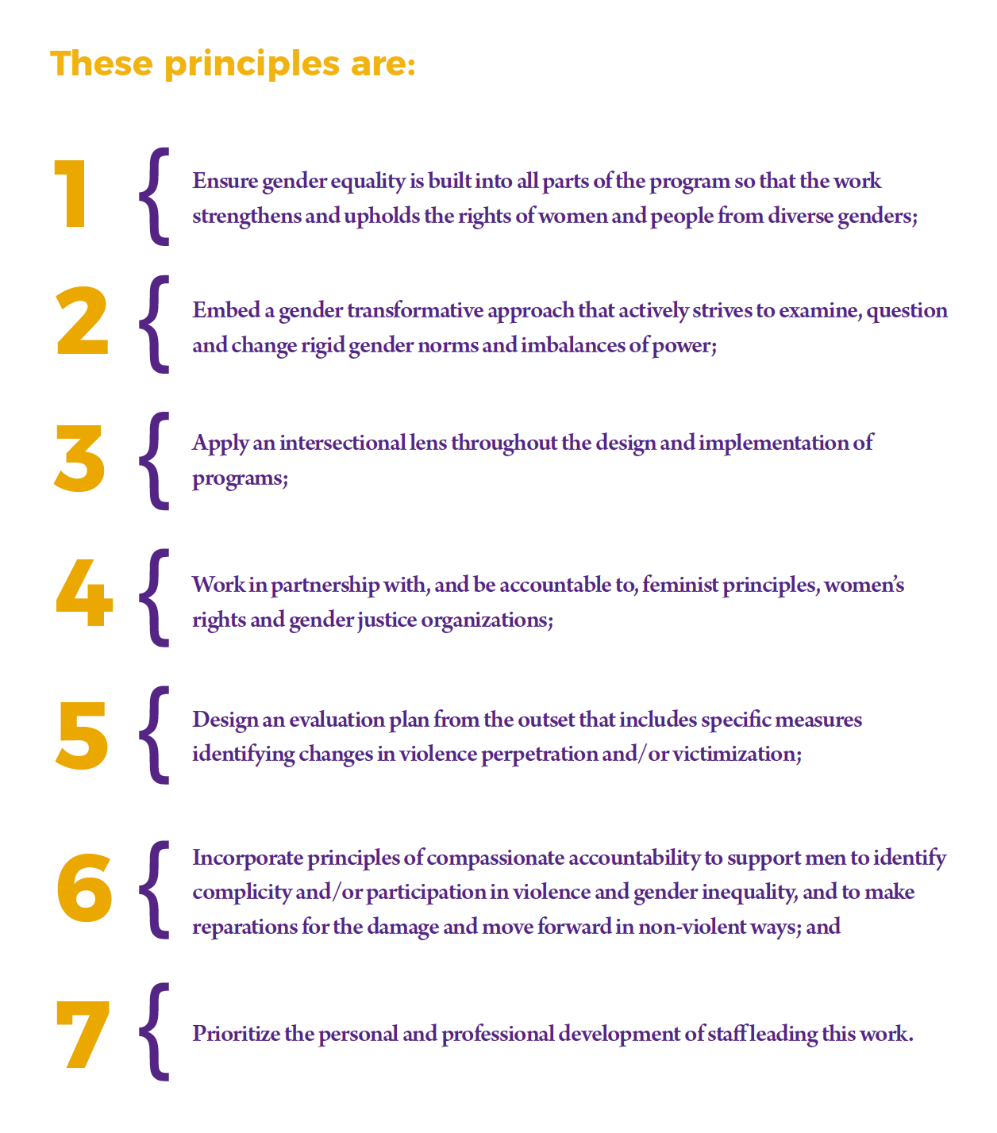

URL: https://preventdomesticviolence.ca/supporting-best-practices-guidelines-for-funding-programs-that-engage-and-mobilize-men-boys-in-violence-prevention/

Flood, M. (2018). Engaging Men and Boys in Violence Prevention, Palgrave Macmillan.

“there also are consistent themes in reviews of other fields of violence prevention practice. Although there is not sufficient evidence to say with certainty what dimensions of violence prevention practice are necessary (or indeed sufficient) to generate a significant and positive impact, the following four features receive consistent emphasis in the literature: violence prevention should be (1) informed; (2) comprehensive; (3) engaging; and (4) relevant.
- Informed: Violence prevention interventions must be based on a sound understanding of both the problem – the workings and causes of violence – and of how it can be changed. In other words, they must incorporate both an appropriate theoretical framework for understanding violence and a theory of change. I return to this below.
- Comprehensive: Effective interventions are likely to be comprehensive: they use multiple strategies, in multiple settings, and at multiple levels (Casey & Lindhorst, 2009; Nation et al., 2003). For example, they incorporate strategies addressing individuals, peer groups, and communities and have multiple strategies addressing the same outcome. This feature of effective practice is the focus of Chapter Nine.
- Engaging: Violence prevention programs should involve effective forms of delivery which engage participants. More effective interventions will have appropriate content (in their educational curricula, their social marketing materials, and so on), be implemented in well-designed and organised ways, and involve skilled personnel (whether educators, advocates, or others). These issues are the focus of Chapter Six.
- Relevant: Good practice programs are relevant to the communities and contexts in which they are delivered. They are informed by knowledge of their target group or population and their local contexts (Nation et al., 2003). This feature of effective practice is the focus of Chapter Eleven.”

Source: Flood, M. (2018). Engaging Men and Boys in Violence Prevention, Palgrave Macmillan (pp. 75-76).
URL (Free in PDF): https://xyonline.net/content/new-book-engaging-men-and-boys-violence-prevention

Flood, M., L. Fergus, and M. Heenan. (2009). Respectful Relationships Education: Violence prevention and respectful relationships education in Victorian secondary schools. Melbourne: Department of Education and Early Childhood Development, State of Victoria.

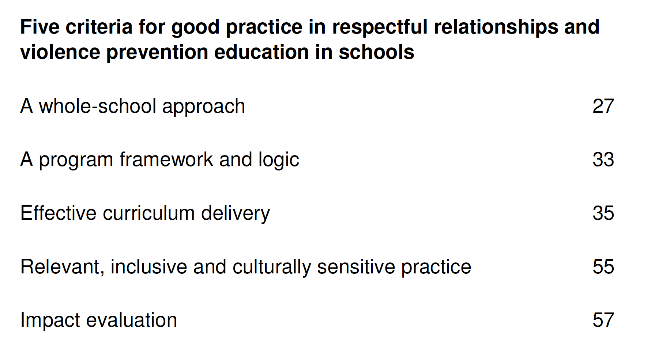
URL: http://xyonline.net/content/respectful-relationships-education-violence-prevention-and-respectful-relationships

In more detail

(1) A whole-of-school approach
Programs should be based on a whole-of-school approach, operating across:
- Curriculum, teaching and learning;
- School policy and practices;
- School culture, ethos and environment;
- The relationships between school, home and the community.
A whole-of-school approach involves;
- Comprehensive curriculum integration;
- Assessment and reporting;
  - Standards and accountability systems: Collection of data on students’ outcomes and competencies and on school climate.
- Specialised training and resources for teaching and support staff;
- Reinforcement of violence prevention programming through school policies, structures, and processes.

(2) A program framework and logic
Programs should:
- Incorporate an appropriate theoretical framework for understanding violence, which:
  - Addresses the links between gender, power, and violence, examining violence-supportive constructions of gender and sexuality, and fostering gender-equitable and egalitarian relations.
- Incorporate a theory of change – an account of the ways in which project content and processes will be used to achieve the project’s intended outcomes.

(3) Effective curriculum delivery
This has four dimensions: content, delivery (teaching methods), structure (duration and intensity, timing, and group composition), and staff (teachers and educators)

a) Curriculum content
Programs should:
- Be informed by feminist scholarship on violence against girls and women;
- Address various forms of violence;
- Target the antecedents to or determinants of violent behaviour;
- Address not only attitudes but also behaviours, interpersonal relations, and collective and institutional contexts.

b) Curriculum delivery (teaching methods)
Programs should:
- Be interactive and participatory.
- Involve the use of quality teaching materials.
- Address cognitive, affective, and behavioural domains.
- Be matched to stages of change.
- Give specific attention to skills development.
- Respond appropriately to participants’ disclosures of victimisation and perpetration.

c) Curriculum structure
Programs should:
- Be of sufficient duration and intensity to produce change.
- Be timed and crafted to suit children’s and young people’s developmental needs, including their developing identities and social and sexual relations.
- Have clear rationales for their use of single-sex and/or mixed-sex groups, including an understanding of the merits and drawbacks of each.

d) Staff: teachers and educators
Programs should:
- Be delivered by skilled teachers and/or educators;
  - Supported by resources, training, and ongoing support.
- Have clear rationales for their use of teachers, community educators, and/or peer educators;
- Have clear rationales for, or a critical understanding of, their use of female and/or male staff.

(4) Relevant, inclusive, and culturally sensitive practice
Programs should:
- Be relevant, that is, informed in all cases by knowledge of their target group or population and their local contexts.
- Be inclusive and culturally sensitive, embodying these principles in all stages of program design, implementation and evaluation.
- Involve consultation with representatives or leaders from the population group(s) participating in the program where appropriate.

(5) Impact evaluation
Programs should involve a comprehensive process of evaluation, which at minimum:
- Reflects the program framework and logic;
- Includes evaluation of impact or outcomes, through;
  - Pre- and post-intervention assessment.
  - Long-term follow-up.
- Includes a process for dissemination of program findings in the violence prevention field.
And which ideally includes:
- The use of standard measures or portions of them;
- Longitudinal evaluation including lengthy follow-up at six-months or longer;
- Measures of not only attitudes but also behaviours;
- Examination of processes of change and their mediators;
- Experimental or quasi-experimental design incorporating control or comparison schools, students, or groups.

Michau, L., Horn, J., Bank, A., Dutt, M., & Zimmerman, C. (2015). Prevention of violence against women and girls: lessons from practice. The Lancet, 385(9978), 1672-1684.

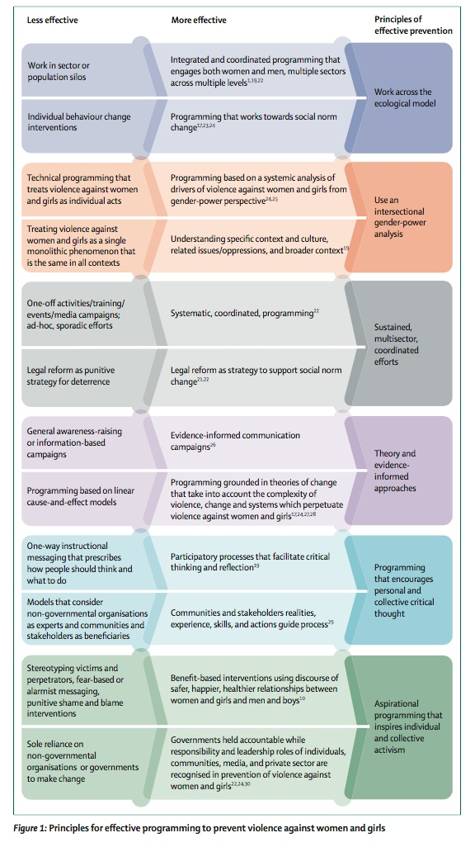
URL: http://xyonline.net/sites/xyonline.net/files/Michau%2C%20Prevention%20of%20violence%20against%20women%20and%20girls%20Lancet.pdf

